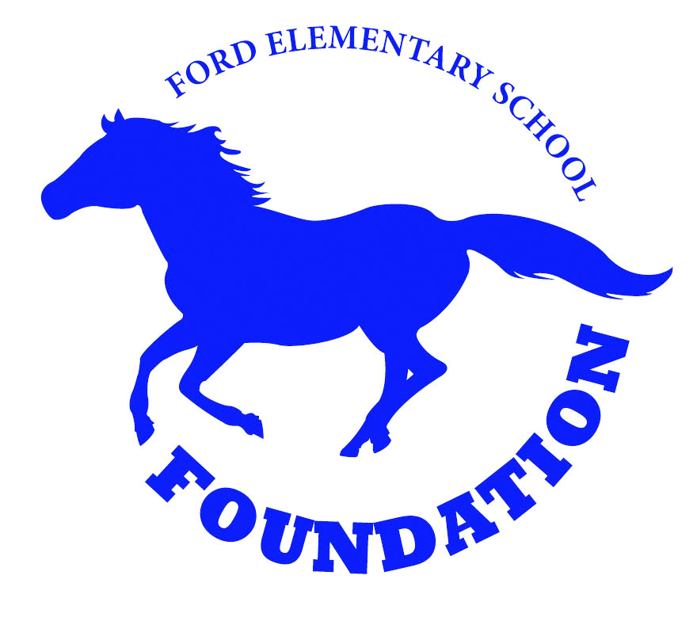

4 x 8 Brick
Order Form
Buy a Brick. Leave a Legacy!

Ford Elementary School Foundation appreciates your purchase of a personalized, engraved brick. All net proceeds will help fund enhanced educational opportunities that otherwise would not be a part of the Ford Elementary School instructional program. The bricks will be installed in the pathway from our gardens to the playground area.

Please Engrave our 4 x 8” Brick(s) as Follows: Note- any symbol is considered one space (period, comma, dash). All text is centered, unless otherwise noted. ALL LETTERS ARE CAPITALIZED.

EXAMPLE
Brick Purchase Amount:

_____ # of 4 x 8” Bricks at $50 ea.

_____# of Donor Certificate(s) at
$8 each

_____# for 4 x 8” Donor Display
Bricks at $25 each (exact duplicate with felt backing)

Total 4 x 8” Brick Purchase:

$_______________

Comments:

D | E | D | I | C | A | T | E | D |  | T | O | :
S | A | M | P | L | E |  | S | T | U | D | E | N | T
L | O | V | E | - | M | O | M | & | D | A | D |  | 2 | 0 | 1 | 5

4 x 8 Brick

4 x 8 Brick

4 x 8 Brick

Name: _________________________________________________________________________________
Business Name (if applicable): _______________________________________________________________
Student Name(s)/ Grade:____________________________________________________________________
Address: ________________________________________________________________________________
City/State/Zip: ____________________________________________________________________________
Phone: __________________________Email Address:___________________________________________

My payment is enclosed: Cash ______ or Check# ______ payable to “CCSF-FESF.” Please return order form and payment to school in an envelope marked Legacy Bricks.

